I wanted to focus on a project that I knew a little about the topic but broaden my knowledge by using tools and techniques. I chose to study the neighbourhood I just moved into, The Glebe, after Dr. Graham had showed us [Bytown or Bust,](http://www.bytown.net.) which is a website about Ottawa's history, written by local people. With this site I wanted to see what people were talking about in the Glebe. When exploring this site, I found out numerous things, such as this isn't a true source of history, like Wikipedia, it is local people who write articles on this site however there data needs to be verified by one source. You might not necessarily find all the information that you want, on specific items as all the articles in there are mostly what other people want to write about, but you get a sense of what about the neighbourhood, the Glebe, people are interested to talk about.

As Dr. Shawn Graham knows I didn't have a lot time to work on this as I fell behind in the class. I decided to use [voyant tools](http://voyant-tools.org/) because I was already familiar with the website in previous class which I took with Dr. Graham. Voyant tools is a website that looks at the corpus of your text and takes the most frequently used words and graphs it so that you can see the major themes. Using this tool with the website Bytown or Bust, it would allow me to see the major themes that people were talking about in the Glebe.

I initially started off by searching "The Glebe" in the search bar and I was really excited that I got a lot of hits on the Glebe. So I took those hits and put them in chronological order by date, that way I could see if I can uncover a historiography of the Glebe.

|  |  |
| --- | --- |
| Website | Date |
| www.bytown.net/mcelroy.htm | Nov 11 2002 |
| www.bytown.net/gcraig.htm | July 28 2002 |
| www.bytown.net/oldfolks.htm | December 6, 2002: |
| www.bytown.net/waddell.htm | Jan 1 2003 |
| www.bytown.net/fitzpatw.htm | January 26, 2003 |
| www.bytown.net/pretoria.htm | Jan 31 2003 |
| www.bytown.net/orr.htm | Feb 11 2003 |
| www.bytown.net/graham.htm | Dec 29 2003 |
| www.bytown.net/movers.htm | Sept 3 2004 |
| www.bytown.net/riellyetc.htm | Sep 15 2004 |
| www.bytown.net/bellscor.htm | Feb 28 2005 |
| www.bytown.net/glashan.htm | Oct 19, 2005 |
| www.bytown.net/turgeonmayor.htm | April 13, 2006 |
| www.bytown.net/holiness.htm | Jul 25, 2007 |
| www.bytown.net/ottawacrest.htm | Apr 17 2008 |
| www.bytown.net/streetcars.htm | July 21 2008 |
| www.bytown.net/conlonpatrick.htm | February 24, 2009 |
| www.bytown.net/canalfrancophones.htm | Mar 20 2009 |
| http://www.bytown.net/mlhickey.htm | Mar 29 2009 |
| www.bytown.net/freepress.htm | Dec 24, 2009 |
| www.bytown.net/coliseumatottawa.htm | Oct 6 2010 |
| www.bytown.net/lowertown.htm | Nov 18 2010 |
| www.bytown.net/rarebooks.htm | Dec 8 2010 |
| www.bytown.net/mcandrewsjohn.htm | Mar 12 2011 |
| www.bytown.net/morozuk.htm | April 16, 2011 |
| www.bytown.net/briandoy.htm | Sep 28, 2012 |
| http://www.bytown.net/hickey.htm | October 1 2012 |
| www.bytown.net/workingclassottawa.htm | Dec 16 2012 |
| www.bytown.net/parliam.htm | April 22 2013 |
| www.bytown.net/varineusebe.htm | Aug 21 2013 |
| www.bytown.net/**Glebe**.htm | Dec 30 2014 |

I plugged in all of these sites, hoping to find a main theme that I can explore, something about the Glebe that I can create an argument. Figure 1, shows voyants results. As you can see Fitzpatrick was one of the words that came up, and I got super excited that I can talk about this guy in my project. Upon further investigation, William Fitzpatrick did not belong in the Glebe or even lived in the Glebe. He was from Carleton County, which is nowhere near the Glebe. So back to square one.

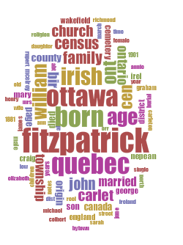

Figure 1: This shows the results from Voyant, when you plug in all the sites listed above.

I did not want to give up on all the sites that I had looked into when searched "The Glebe" on Bytown or Bust. So I had plugged in the first five years on my list.

|  |  |
| --- | --- |
| www.bytown.net/mcelroy.htm | Nov 11 2002 |
| www.bytown.net/gcraig.htm | July 28 2002 |
| www.bytown.net/oldfolks.htm | December 6, 2002: |
| www.bytown.net/waddell.htm | Jan 1 2003 |
| www.bytown.net/fitzpatw.htm | January 26, 2003 |
| www.bytown.net/pretoria.htm | Jan 31 2003 |
| www.bytown.net/orr.htm | Feb 11 2003 |
| www.bytown.net/graham.htm | Dec 29 2003 |
| www.bytown.net/movers.htm | Sept 3 2004 |
| www.bytown.net/riellyetc.htm | Sep 15 2004 |
| www.bytown.net/bellscor.htm | Feb 28 2005 |
| www.bytown.net/glashan.htm | Oct 19, 2005 |
| www.bytown.net/turgeonmayor.htm | April 13, 2006 |

Here I was hoping to find someone or something that started off the Glebe, maybe about the founding fathers, or about the settlers who first lived in the neighbourhood. Again, my results excited me as I got hits but not necessarily hits that I wanted.

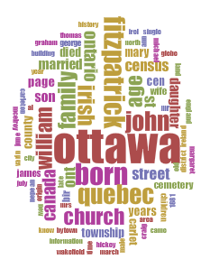

Figure 2: Results from voyant after plugging in the first five years.

I thought that the Irish could be something I talked about in my project however upon further research, they too did not settle in the Glebe, in fact they settled in lowertown which is nowhere near the Glebe. I thought to myself, there must be something I'm doing wrong.

What I realized was that Bytown or Bust was giving me all the websites that have the word 'Glebe' in it even though it only mentions the word once, and most cases not even giving information on the Glebe but saying that "if I am interested in this topic I should look into the Glebe" These sites were not helpful as these websites had nothing to do with the topic I was interested in. So Again, I started over, but instead of plugging in numerious sites into voyant. I just plugged in the one that was talking about the evolution and history of the Glebe..

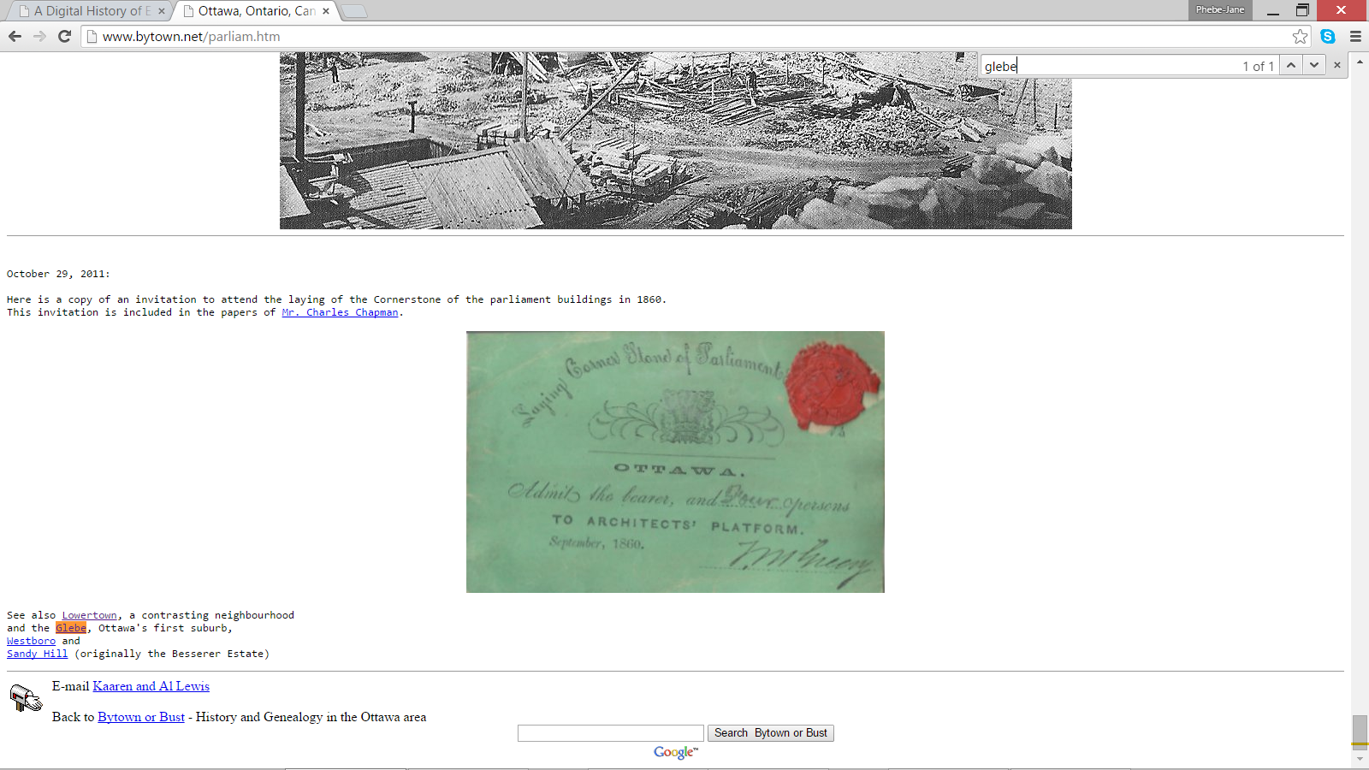

Figure 3: This shows the results of one of the websites, when I used the function "CTRL + F" and searched for Glebe.

Before plugging the sitehttp://www.bytown.net/glebe.htm, I had to make sure that this was the information I wanted. I read through the headings. It gave me headings of geography/topography, political factors, architecture, all pertaining to the Glebe. Figure 4 shows the results when I plugged in that site.

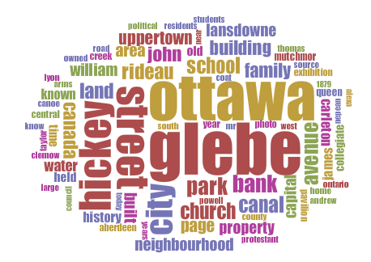

Figure 4: Results from voyant when plugging in http://www.bytown.net/glebe.htm  
Here is the unique voyant url if you want to explore it further, <http://voyant-tools.org/?corpus=1428543446783.7606&stopList=stop.en.taporware.txt>

It was a relief seeing works that I knew were connected to the glebe, such as canal, Lansdowne, Carleton and Bank. I also was excited to see topics that about the Glebe that I've never heard before, such as Hickey, which I found out was the earliest Roman Catholic landowners in the Glebe. Yay! A founding family of the Glebe. Also Roman Catholic, what makes me question if the Glebe started off as a Roman Catholic community, however upon further reading into the corpus we know that the community was exclusively white and protestant. This got me questioning why protestant did not show up in the voyant graph and when doing a "CTRL + F" search on the topic, it only shows up in my corpus 6 times. Another interesting thing that shows up in the corpus is Lansdowne, we all know Lansdowne now as being a new hip place to go shopping, and to try the new restaurants that are there, or maybe even enjoy a Redblacks game or a 67s game. I don't know when this site was last updated as those things are not mentioned in the website, just about the history of Lansdowne and the famous Cattle Castle.

It seems as though the members of the Bytown of Bust website are more particularly interested in history and the evolution of the city rather than updating it frequently about what is new and exciting in the city. Looking through the site, not even looking at the glebe, it seems as through they are interesting in finding founding families of Ottawa and about heritage homes. It does not seem to be concerned with any new neighbourhoods or communities that are starting to pop up in Ottawa.

If I had more time on this project it would be interesting to see if I can find a site that isn't a site that showcases public history. Maybe if I found a book or either news clippings (hopefully articles that I can find online that way I can extract them), a secondary source document on the glebe so that I may compare the results from Bytown or Bust to the results from the secondary source document. It would be interesting to see whether or not they will have the same topics or different topics all together. That way we can see what the scholars what us to know and that the locals adding articles to a website want us to know and made an argument that way.

Unfortunately because father time was ticking down my back I did not have the opportunity to explore other methods learned in class, and it would have been fun to make a poster or even a website of my own to display by data, but a las the last day of classes came faster than I expected it to come. It was fun learning from Dr. Graham again, I believe he pushes his students to find abilities that they did not think they have until they take one of his classes, he's method to his madness definitely opened a lot of doors for me and taught me close reading in long texts that I did not want to read! SHHHH!